4.9 Newton’s Method

Motivation: Suppose we wish to find positive root of the function to a high level of accuracy.
We can easily see that the positive root is but we want to have a decimal approximation of this number that is very accurate.

The General Derivation of Newton’s Method

The main idea: We use tangent lines toto help find roots of .

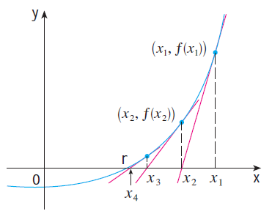

Note: Not all sequences of approximations will converge to r…we need to have a good starting approximation for .

Note: In more advance mathematics classes, namely numerical analysis, one can study conditions under which Newton’s method will be successful. In other words, we can make the idea of our initial guess being “sufficiently close” to the desired root precise. In this class we will not study such conditions. Rather, we will judge the reasonableness of our results by using the calculator.

Example 1: Starting with find the fourth approximation via Newton’s method to the positive root of the equation .

Example 2: Starting with , find the 3rd approximation to the solution of the equation .

This process can also be complete using the calculator by doing the following:
- Type in your initial guess and store this value to A:
- Then on the calculator you enter:
- This will use the initial value to calculate and then change the value of A to this new value.
- Hit enter to obtain each new approximation.

Example 3: Find, correct to six decimal places, the solution of the equation .

Example 4: Use Newton’s method to find correct to six decimal places.

